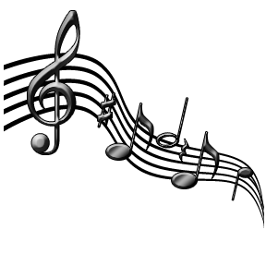
Norwalk Catholic Schools Music Department

Attention 5th grade future band members!

There will be a beginning band informational meeting on Tuesday, August 30th at 7:00pm in the high school auditorium. I will be there to explain how beginning band works at Norwalk Catholic Schools and to answer any questions you may have.

The 5th grade is an excellent time for a student to start a band instrument. Students who start playing an instrument in the 5th grade are more likely to be successful than those who wait until they are older to begin.

Did you know that people who begin to play a musical instrument have shown the following improvements: Improvement in Performance on Cognitive Tasks, Increased Memory Capacity, Refined Time Management and Organizational Skills, Enhanced Coordination, Better Mathematical Ability, Stronger Self-Discipline, Responsibility and Perseverance.

During the evening there will be the opportunity to see the instruments and for your student to try the instruments again. The 5th grade student will be able to choose from the following instruments: flute, clarinet, saxophone, trumpet, trombone and percussion. These are the common instruments students begin their instrumental experience with.

Representatives from the music stores, Forte Music and Rettig Music, will also be there to explain their policies on renting or buying an instrument.

I look forward to seeing you and your 5th grade prospective band member on Tuesday, August 30th at 7:00 p.m.

Musically yours,
Christopher R. Clark
cclark@ncsmail.org

